Develop a vb project to draw an graph based on user input

Form design
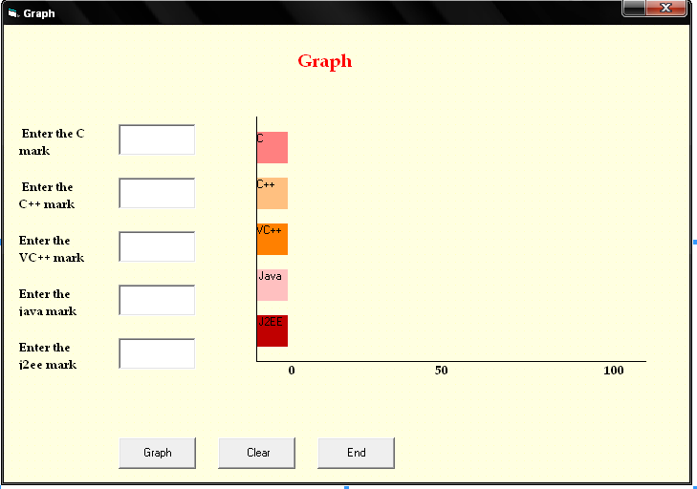

Properties:
Controls | Name | Caption
Text1 | Text1
Text2 | Text2
Text3 | Text3
Text4 | Text4
Text5 | Text5
Command1 | Cmdgraph | Graph
Command2 | Cmdclear | Clear
Command3 | Cmdend | End
Label7 | Label7 | C
Label8 | Label8 | C++
Label9 | Label9 | VC++
Label10 | Label10 | Java
Label11 | Label11 | J2EE

12.Graph
Aim:
To develop a vb project to draw an graph based on user input

Coding:
Dim a, b, c, d, e As Integer
Private Sub Cmdgraph_Click()
a = Val(Text1.Text)
b = Val(Text2.Text)
c = Val(Text3.Text)
d = Val(Text4.Text)
e = Val(Text5.Text)
Label7.Width = Label7.Width + a * 50
Label8.Width = Label8.Width + b * 50
Label9.Width = Label9.Width + c * 50
Label10.Width = Label10.Width + d * 50
Label11.Width = Label11.Width + e * 50
End Sub

Private Sub Cmdclear_Click()
Text1.Text = " "
Text2.Text = " "
Text3.Text = " "
Text4.Text = " "
Text5.Text = " "
Label7.Width = 500
Label8.Width = 500
Label9.Width = 500
Label10.Width = 500
Label11.Width = 500
End Sub

Private Sub Cmdend_Click()
End
End Sub

Output:

